Gambar Final Wiring Robot Pembersih Kaca Dan Hubungan Pinnya
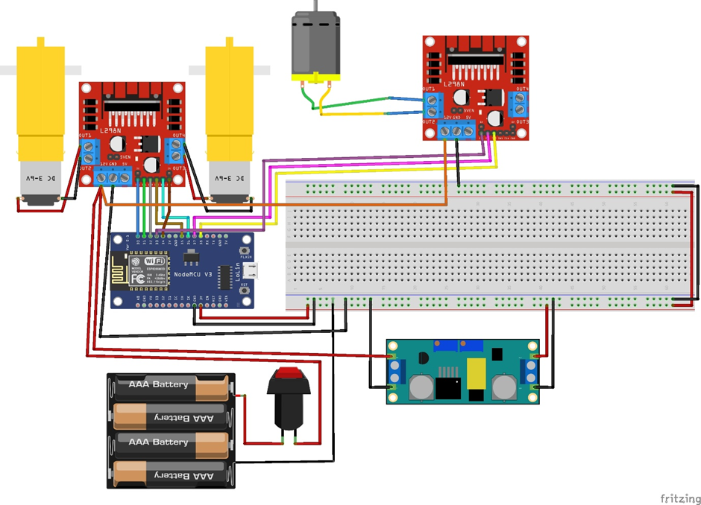

- Pin L298N Ke Pin ES8266
Pin L298N | Pin ESP8266
L298N-(1) IN1 | D1
L298N-(1) IN2 | D2
L298N-(1) IN3 | D5
L298N-(1) IN4 | D6
L298N-(2) IN1 | D7
L298N-(2) IN2 | D8
L298N-(1) ENA | D0
L298N-(1) ENB | D4
L298N-(2) ENA | D3

- Pin L298N Ke Motor DC
Pin L298N | Motor DC
L298N-(1) OUT1 | Motor 1 (+)
L298N-(1) OUT2 | Motor 1 (-)
L298N-(1) OUT3 | Motor 2 (+)
L298N-(1) OUT4 | Motor 2 (-)
L298N-(2) OUT1 | Motor 3 (+)
L298N-(2) OUT2 | Motor 3 (-)

- Pin Volt Dan Pin Grounding
Volt | Grounding
Battery (+) | Battery (-)
ESP8266 (3V) | ESP8266 (GND)
Step Down XL4015 (IN+) | Step Down XL4015 (IN-)
Step Down XL4015 (OUT+) | Step Down XL4015 (OUT-)
L298N-1 (12V) | L298N-1 (GND)
L298N-2 (12V) | L298N-2 (GND)

